**UNIVERSITY OF ENERGY AND NATURAL RESOURCES**

**UENR 202: SCIENCE, ENERGY AND TECHNOLOGY**

**SOLAR ENERGY IMPACT AND IT IMPORTANCE IN GHANA.**

**Deborah Nketsiah UEB 1301421**

**Jessica Afful UEB1301321**

**Agyei Dede Magareta UEB1303421**

# ABSTRACT

Solar power generation has become increasingly popular as a means of generating energy while mitigating the emission of harmful greenhouse gases that contribute to climate change and environmental problems. The aim of this study is to investigate the influence of a growing population on solar energy production in Ghana, examine how environmental conditions can affect solar appliances, assess the environmental impact of batteries used for storing solar energy, and explore how solar energy generation can contribute to ecosystem equilibrium. This research primarily relies on existing secondary data sources.

Our findings reveal a rapid global population increase, nearly 1.5 times from 5.3 billion in 1990 to 7.3 billion in 2014, with an average annual growth rate of 1.3%, which significantly impacts energy consumption in a detrimental manner. Additionally, solar panels can be adversely affected by the accumulation of small water droplets, causing sunlight to scatter and reduce the amount of solar radiation necessary for energy generation. Furthermore, improper disposal of batteries used in solar energy storage can pose risks to both human health and environmental quality, releasing various pollutants such as heavy metals and hydrofluoric acid (HF). In summary, this study highlights the repercussions of solar energy generation on diverse ecosystems and offers insights into enhancing the environmental impact of used solar energy storage batteries.

**Keywords.**

Solar energy, Photovoltaic cells, batteries.

# INTRODUCTION

Renewable Energy and the Environment covers solar energy resources, thermal and photovoltaic systems, and the economics involved in using solar energy (foster et al,2009).The depletion of natural resources that supports human lives and consumption have continuously forced us to discover renewable energy sources, like solar, wind, biomass, and hydropower, to support economic development in the future.(NA,2012). Solar energy travels at a speed of 186,000 miles per second. Only a small part of the radiant energy that the sun emits into space ever reaches the Earth, but that is more than enough to supply all our energy demand. (Handayani and Ariyanti,2012). The effective use of solar energy requires a storage medium that can facilitate the storage of excess energy, and then supply this stored energy when it is needed (Mofijur et al,2009).The energy from the sun can be converted into electricity or used directly. Electricity can be generated from solar energy either directly using photovoltaic (PV) cells or indirectly using concentrated solar power (CSP) technology. (Hayat et al,2018). The cells-constructed from single, crystal, polycrystalline and amorphous semiconductors-and the systems-have varying designs and differing levels of solar energy for input and produce electricity or electrical and thermal energies. Solar cell production, economics and environmental effects are considered throughout the publication. (Neville,1995).Presently, solar energy conversion can be used to produce and generate electricity for individual and for various forms of industries. (Mekhilef et al,2011).By providing solar energy to the individual, an energy supply becomes secure and available to people of both legacy and nonlegacy worlds and contributes to a decrease in the anthropogenic levels of carbon dioxide. (Nocera,2009).Daunting challenges of most societies is as a result of limited in supply of clean energy. Sunlight provides by far the largest of all carbon-neutral energy sources. More energy from sunlight strikes the Earth in one hour (4.3? 1020 J) than all the energy consumed on the planet in a year (4.1? 1020 J) (Lewis et Al,2005) Global transmission of energy has been annually accounted for by increase in energy consumption together with environmental issues and concerns that has impacts on how sustainable and renewable energies can be. Solar energy systems have been grabbing most attention among all the other renewable energy systems throughout the last decade. (Rabaia et Al, 2021). one of the cleanest energy sources and is touted as a potential renewable energy source for the world with benefits such as reducing CO2 emissions, reversing global warming by being eco-friendly, and bringing innovation to sustainable aquaculture and potential cost-efficiency for manufacturing.(Vo et al,2021). Photovoltaics is the direct conversion of light into electricity at the atomic level (Kiner,2002). One of the largest businesses currently emerging in any sector of the economy is the conversion of the sun’s radiation into energy. (ginley et Al,2008). Among other forms of energy, solar energy is clean, environmentally friendly and freely available over the planet earth. Life on earth also owes its existence to solar energy. Solar energy is used to produce thermal as well as electrical power. (Tiwari, 2016). Rapid growth within the field of solar technologies is nonetheless facing various technical barriers, such as low solar cell efficiencies, low performing balance-of-systems (BOS), economic hindrances (e.g., high upfront costs and a lack of financing mechanisms), and institutional obstacles (e.g., inadequate infrastructure and a shortage of skilled manpower. (Kabir et Al,2018) New developments in nanotechnology, biotechnology, and the materials and physical sciences may enable step-change approaches to cost-effective, globally scalable systems for solar energy use. (Lewis,2007). Solar radiation data provide information on how much of the sun's energy strikes a surface at a location on the earth during a particular time period. (Khatib et al,2012). Solar radiation is a vital part of different renewable energy resources. It is the main and continuous input variable from practically inexhaustible sun. [(Sen,2004)](#_Şen,_Z._(2004,). Solar energy sub-disciplines range from solar radiation and meteorology, solar collectors and concentrators, solar energy and the built environment, to solar thermal electricity, photovoltaics, wind energy and the potential cost of ignoring solar energy resources. (Gordon et Al, 2001). Since solar energy is superior in terms of availability, cost effectiveness, accessibility, capacity and efficiency compared to other renewable energy sources, it would be the best option to focus on. (Kannan and Vakeesan,2016).

# Primary objectives

The primary objectives of this project are to;

1. Consider the effect of population growth in Ghana on solar energy generation.
2. Know how climatic conditions such as rain can affect solar in Ghana.
3. Look at the effects of batteries used in storing solar energy on Ghana’s environment.

# Secondary objectives

The secondary objectives of this project are;

1. To know how solar energy generation can help in balancing ecosystems.

The objectives outlined above will be supported by the utilization of secondary data. This type of data involves the use of information that has already been gathered by other individuals or organizations and is readily available for research purposes. Secondary data serves as a valuable tool, offering context to a study that might otherwise have limited scope. It also proves to be a efficient means of consolidating a substantial volume of data, particularly in cases where accessing primary field data might be challenging. This approach promotes the creation of high-quality databases that can contribute to addressing issues concerning the impact of solar energy generation on the environment (Smith, 2008). Employing secondary data not only helps in cost reduction and time savings but also enhances our comprehension of the problem at hand..

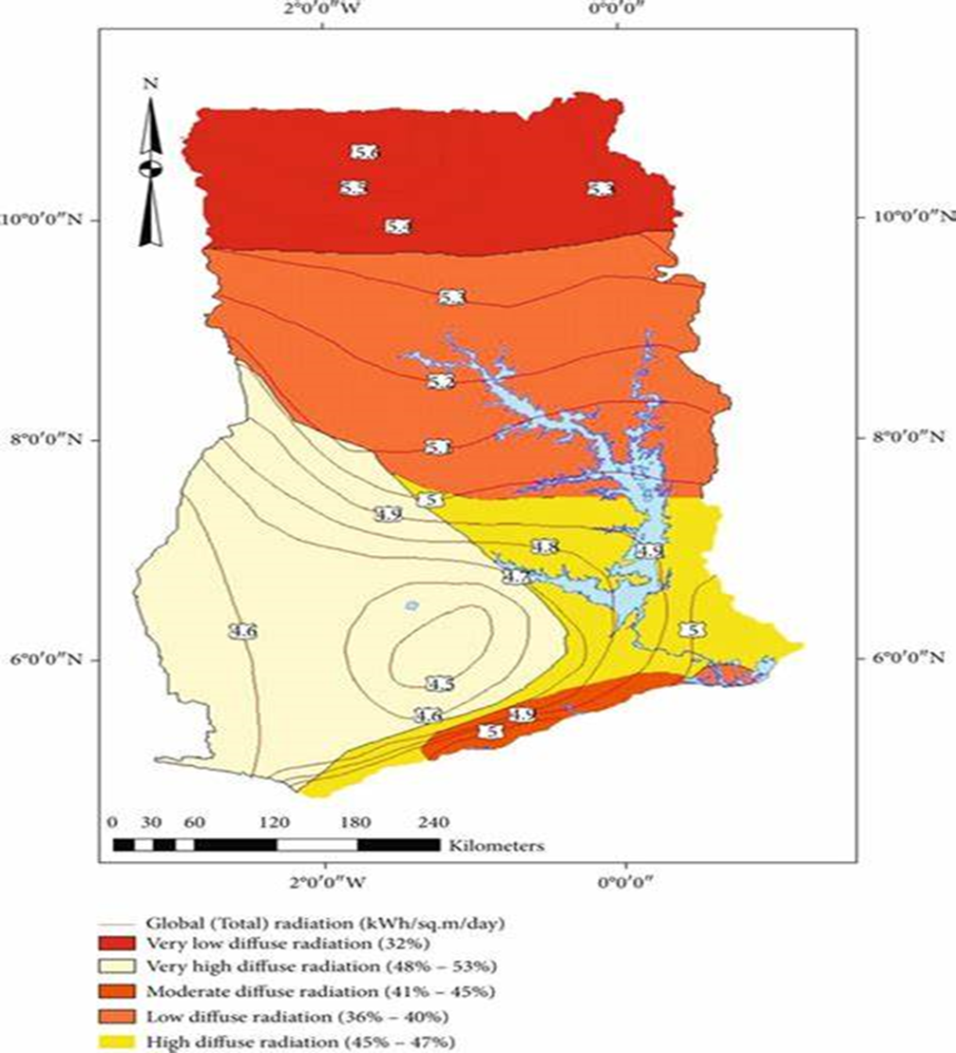

Fig1.1

source: Microsoft search

The figure above shows an overview of the scientific production of solar energy in Ghana.

**The effect of population growth in Ghana on solar energy generation.**

When energy is scarce or expensive, people can suffer material deprivation and economic hardship. much of the world's population has too little energy to meet basic human needs; the monetary costs of energy are rising nearly everywhere; the environmental impacts of energy supply are growing and already dominant contributors to local, regional, and global environmental problems (including air pollution, water pollution, ocean pollution, and climate change); and the sociopolitical risks of energy supply (above all the danger of conflict over oil and the links between nuclear energy and nuclear weapons) are growing to. The global population size has risen rapidly (approximately 1.5 times) from 5.3 billion in 1990 to 7.3 billion in 2014, with an average annual growth rate of 1.3% . One of the consequences of such economic and population growth on Ghana’s economy is rapidly increasing energy consumption. Based on statistics from BP (formerly British Petroleum) , global energy consumption has increased by approximately two times, from 8133.3 million tones oil equivalent (Mtoe) in 1990 to 12,928.4 Mote in 2014 .( Dong et al, (2018).

Generation of new employment opportunity is one of the most positive long-term effect of renewable energy in Ghana. Government bodies and policymakers have also supported the domestic market in renewable energy technology business by providing tax benefits, flexible and investment friendly norms. In 2009, 1.4 billion people did not have access to electricity, 85% of them belongs from rural areas. By 2015, 1.2 billion more people will need access to electricity and 1.9 million more people will need access to modern fuels to meet the Millennium Development Goal of reducing the number of people below poverty level by half. This is more effective and fruitful in rural areas ,  with the help of small and standalone Renewable Energy configurations like solar (PV), hydropower and [bioenergy](https://www.sciencedirect.com/topics/engineering/bioenergy) meeting the local energy demand of rural communities in a cheaper and cleaner ways. For example, PV is an attractive form to fulfill very basic needs like lighting, clean drinking water. (Sen and Ganguly (2017).

However, population growth in the Ghanaian urban areas and the high energy consumption per unit area compared to the low solar energy capture by Photovoltaic (PV) systems makes solar PV energy systems investment an unattractive venture for most urban settlers. Because building architectures mostly do not incorporate solar PV systems in facility planning, most building roofs pose challenges for solar PV array installation leading to lower PV energy output. (Frimpong et al ,2020). The rapidly increasing energy demand, has posed tremendous environmental challenges the Ghanaian environment, particularly the global climate change caused by the increased concentration of carbon dioxide (CO2) emissions mainly emitted from fossil fuel burning. Fossil fuel-based global CO2 emissions have increased by around two times from 22.7 billion tons in 1990 to 35.5 billion tons in 2014. Subsequent findings of the generalized method of moments (GMM), generalized linear model (GLM), and robust least-squares reveal an inverse relationship of natural resources and renewable energy consumption with the ecological footprint and CO2 emissions, while non-renewable energy consumption, population growth, and biocapacity have a positive relationship with the ecological footprint and CO2 emissions. Overall, our findings suggest that natural resources and renewable energy consumption improve environmental quality in the long run, while population growth and non-renewable energy consumption contribute to its deterioration. (khan et al,2021).

**The effects climatic conditions on solar appliances in Ghana**.

Dew formation occurs frequently in various climates including in semi-arid regions suitable to PV cell deployment. Then, droplets present on the cover of solar cells can negatively affect the cell power generation and efficiency due to optical effects. Tiny water droplets, or water vapor, can collect on solar panels (like beads of sweat) and reflect or refract sunlight away from solar cells. This reduces the amount of sunlight hitting them and producing electricity. Concentrated Solar Power systems, direct solar radiation is concentrated in order to obtain (medium or high temperature) thermal energy that is transformed into electrical energy by means of a thermodynamic cycle and an electric generator. Direct solar radiation is concentrated in order to obtain high temperature (approximately between 500 and 1000 °C) thermal energy that is transformed into electrical energy .( Merchán, R. P, (2022).

**The effects of batteries used in storing solar energy has on Ghana’s environment.**

Batteries of various types and sizes are considered one of the most suitable approaches to store energy and extensive research exists for different technologies and applications of batteries; however, environmental impacts of large-scale battery use remain a major challenge that requires further study

Construction of solar power plants, in particular, is more technologically invested than other power plants construction processes, due to the effects of any unpredicted or neglected soil/land factor on the system's consistency, efficiency, and performance over its lifetime. Therefore, significant landscape modifications are usually required, such as vegetation removal, land leveling, soil compaction, unneeded roads removal, and construction of main access roads. This can lead to increased erosion of the [topsoil](https://www.sciencedirect.com/topics/earth-and-planetary-sciences/topsoil) or even deeper levels, [turbidity](https://www.sciencedirect.com/topics/earth-and-planetary-sciences/turbidity) or sediment load increase in local streams, filtration reduction of rainwater and [air pollutants](https://www.sciencedirect.com/topics/earth-and-planetary-sciences/air-pollutant), [groundwater recharge](https://www.sciencedirect.com/topics/earth-and-planetary-sciences/groundwater-recharge) reduction, and the probability of [flooding](https://www.sciencedirect.com/topics/earth-and-planetary-sciences/flood). As with any type of power plant, large solar power plants can affect the environment at or near their locations. Clearing land for construction and the placement of the power plant may have long-term effects on the habitats of native plants and animals. Water requirements vary from phase to phase across the solar power plant's life cycle, but it is required from the first stage of the construction phase until the last stage of the decommissioning phase. The land leveling process in the construction phase, dust suppression requires the most consumption rate of water. In contrast, water's consumption rate can differ depending on the technology, whether its CSP or PV, as well as the used cooling system, whether it's wet, dry or hybrid. The hybrid technology requires 65–80% lower water consumption of 600–1300 L/MWh). (Rabaia et al, (2021).

Due to excessive quantities of lead, such Lithium-ion batteries could be listed as dangerous waste according to the TCLP findings (Pb). Randhawa and Chopra (2022). .Human health and environmental quality could be placed at risk as a wide range of pollutants could be released like heavy metals or hydrofluoric acid (HF) when batteries are disposed of inappropriately. (Mrozik et al, (2021).

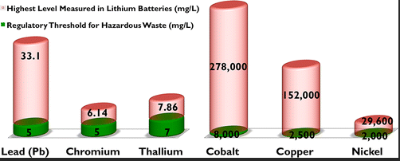

Fig.1.3 source: google

From the above diagram, it shows that batteries have more effect on the environment and measures taking to reduce it effects needs to be more effective.

**How solar energy generation can help in balancing ecosystems.**

An important reason for replacing fossil fuels with renewable energy is to promote ecological sustainability—in particular to minimize further climate change. The natural world provides many ecosystem services, such as provision of food, fresh water, and climate regulation. (Moriarty, P, (2016).Solar energy is amongst the cleanest forms of energy having the potential of 6500 TW that is capable enough to meet a substantial portion of the world's energy demand. It has tremendous environmental advantages over traditional energy sources that are; reducing CO2 emission and other toxic gas emissions like SO2, mitigating natural resources depletion, providing energy independence and security, enhancing the quality of water resources, and contributing to sustainable development and also enhancing the ecosystems. (Kuşkaya et al, (2023). Solar energy creates circulation of wind and ocean water, causes water evaporation and consequent precipitation. Plants use solar energy for photosynthesis and store carbohydrates, protein, fats, oils, alcohols, cellulose and lignin for its growth to balance the ecosystem. (Ali et al, (2012).However, the environmental impacts of utility­-scale solar energy (USSE) play out across multiple scales, locally affecting ecological communities ranging from soil microbiota to old-growth vegetation and more broadly affecting migratory wildlife and landscape processes such as soil and water distribution. Paradoxically, by damaging biological soil crusts and affecting deeper soil microbial communities responsible for nutrient cycling, construction of USSE to quell fossil-fuel use may actually release detrimental GHGs, increasing local estimates of relative atmospheric heating capacity, or global warming potential. (Moore‐O'Leary et al,. (2017).

CONCLUSION.

Over the past decade, solar energy systems have garnered significant attention compared to other renewable energy sources, primarily due to the abundant solar energy resource. Solar power is recognized as one of the cleanest energy options and is seen as a promising solution for reducing CO2 emissions and combating global warming through its eco-friendly characteristics. As the global population continues to grow, there is a growing demand for energy, particularly eco-friendly options like solar power. However, it's worth noting that while solar energy has numerous environmental benefits, it is not without its challenges. Various climatic conditions, such as rain, snow, and hail, can impact the efficiency and functionality of solar energy systems. Rainy days, in particular, can hinder solar panels' performance by reducing the amount of sunlight they receive. Moreover, the disposal of batteries used in solar energy systems poses environmental risks. Lithium-ion batteries, commonly used in these systems, contain toxic metals like cobalt, nickel, and manganese, which can leach into water bodies and ecosystems when improperly disposed of in landfills.

Despite these environmental concerns associated with solar energy generation, it also has the potential to contribute positively to ecosystems. It can reduce the emission of toxic gases like CO2 and SO2, mitigate the depletion of natural resources by tapping into the sun's virtually unlimited energy supply, promote energy independence and security, contribute to sustainable development, and enhance overall ecosystem health. This project aims to raise awareness of the environmental impact of solar energy generation on various ecosystems and explore ways to improve the disposal of solar energy storage batteries to minimize their adverse effects on the environment in Ghana. The insights gained from this research can guide solar energy engineers in designing more environmentally friendly solar energy generation equipment. In summary, while solar energy generation is widely accepted as a sustainable and eco-friendly solution, it is essential to address its potential environmental impacts. With proper management and innovation, solar energy can continue to play a crucial role in reducing climate change effects and promoting a more sustainable future.

# REFERENCES

1.Kannan, N., & Vakeesan, D. (2016, September). Solar energy for future world: - A review. *Renewable and Sustainable Energy Reviews*, *62*, 1092–1105. <https://doi.org/10.1016/j.rser.2016.05.022>

2.Granqvist, C. (2003, November 4). Solar Energy Materials. *Advanced Materials*, *15*(21), 1789–1803. <https://doi.org/10.1002/adma.200300378>

3.Lewis, N. S. (2007, February 9). Toward Cost-Effective Solar Energy Use. *Science*, *315*(5813), 798–801. <https://doi.org/10.1126/science.1137014>

4.Mekhilef, S., Saidur, R., & Safari, A. (2011, May). A review on solar energy use in industries. *Renewable and Sustainable Energy Reviews*, *15*(4), 1777–1790. <https://doi.org/10.1016/j.rser.2010.12.018>

5.Neville, R. C., & Loferski, J. J. (1982, April 1). Solar Energy Conversion: The Solar Cell. *Physics Today*, *35*(4), 65–65. <https://doi.org/10.1063/1.2915018>

6.Ginley, D., Green, M. A., & Collins, R. (2008, April). Solar Energy Conversion Toward 1 Terawatt. *MRS Bulletin*, *33*(4), 355–364. <https://doi.org/10.1557/mrs2008.71>

7.Khatib, T., Mohamed, A., & Sopian, K. (2012, June). A review of solar energy modeling techniques. *Renewable and Sustainable Energy Reviews*, *16*(5), 2864–2869. <https://doi.org/10.1016/j.rser.2012.01.064>

8.Hayat, M. B., Ali, D., Monyake, K. C., Alagha, L., & Ahmed, N. (2018, November 5). Solar energy-A look into power generation, challenges, and a solar-powered future. *International Journal of Energy Research*, *43*(3), 1049–1067. <https://doi.org/10.1002/er.4252>

9.Nocera, D. G. (2009, September 23). Chemistry of Personalized Solar Energy. *Inorganic Chemistry*, *48*(21), 10001–10017. <https://doi.org/10.1021/ic901328v>

10.Rabaia, M. K. H., Abdelkareem, M. A., Sayed, E. T., Elsaid, K., Chae, K. J., Wilberforce, T., & Olabi, A. (2021, February). Environmental impacts of solar energy systems: A review. *Science of the Total Environment*, *754*, 141989. <https://doi.org/10.1016/j.scitotenv.2020.141989>

11.Handayani, N. A., & Ariyanti, D. (2012, July 1). Potency of Solar Energy Applications in Indonesia. *International Journal of Renewable Energy Development*, *1*(2), 33–38. <https://doi.org/10.14710/ijred.1.2.33-38>

12.Şen, Z. (2004, January). Solar energy in progress and future research trends. *Progress in Energy and Combustion Science*, *30*(4), 367–416. <https://doi.org/10.1016/j.pecs.2004.02.004>

13Kabir, E., Kumar, P., Kumar, S., Adelodun, A. A., & Kim, K. H. (2018, February). Solar energy: Potential and future prospects. *Renewable and Sustainable Energy Reviews*, *82*, 894–900. <https://doi.org/10.1016/j.rser.2017.09.094>

14.Work on refining thermionic diodes. (2002, March). *Photovoltaics Bulletin*, *2002*(3), 4. <https://doi.org/10.1016/s1473-8325(02)80096-7>

15.Kannan, N., & Vakeesan, D. (2016, September). Solar energy for future world: - A review. *Renewable and Sustainable Energy Reviews*, *62*, 1092–1105. <https://doi.org/10.1016/j.rser.2016.05.022>

16.Tiwari, G. N., & Tiwari, A. (2016). Handbook of Solar Energy. Vol. 498. *Singapore: Springer. https://doi. org/10*, *1007*, 978-981

17.Gordon, J. M. (2001, March). Solar energy engineering. *Refocus*, *2*(2), 34–37. <https://doi.org/10.1016/s1471-0846(01)80007-x>

18.Foster, R., Ghassemi, M., & Cota, A. (2009). Solar energy: Renewable energy and the environment. In Solar Energy: Renewable Energy and the Environment. <https://doi.org/10.5860/choice.47-5672>

19.Mofijur, M., Mahlia, T. M. I., Silitonga, A. S., Ong, H. C., Silakhori, M., Hasan, M. H., Putra, N., & Ashrafur Rahman, S. M. (2019). Phase change materials (PCM) for solar energy usages and storage: An overview. In Energies (Vol. 12, Issue 16). <https://doi.org/10.3390/en12163167>

20.Vo, T. T. E., Ko, H., Huh, J. H., & Park, N. (2021). Overview of solar energy for aquaculture: The potential and future trends. In Energies (Vol. 14, Issue 21). <https://doi.org/10.3390/en142169233>.

21.Thomas, M. (2009). Using Secondary Data in Educational and Social Research - By Emma Smith. British Journal of Educational Technology, 40(4). <https://doi.org/10.1111/j.1467-8535.2009.00994_13.x>

22. Kannan, N., & Vakeesan, D. (2016). Solar energy for future world:-A review. *Renewable and sustainable energy reviews*, *62*, 1092-1105. <https://doi.org/10.1016/j.rser.2016.05.022>

23. Dong, K., Hochman, G., Zhang, Y., Sun, R., Li, H., & Liao, H. (2018). CO2 emissions, economic and population growth, and renewable energy: Empirical evidence across regions. Energy Economics, 75. <https://doi.org/10.1016/j.eneco.2018.08.017>

24.Sen, S., & Ganguly, S. (2017). Opportunities, barriers and issues with renewable energy development – A discussion. In Renewable and Sustainable Energy Reviews (Vol. 69). <https://doi.org/10.1016/j.rser.2016.09.137>

25. Khan, I., Hou, F., & Le, H. P. (2021). The impact of natural resources, energy consumption, and population growth on environmental quality: Fresh evidence from the United States of America. Science of The Total Environment, 754, 142222. <https://doi.org/10.1016/j.scitotenv.2020.142222>

26. Rabaia, M. K. H., Abdelkareem, M. A., Sayed, E. T., Elsaid, K., Chae, K. J., Wilberforce, T., & Olabi, A. G. (2021). Environmental impacts of solar energy systems: A review. Science of the Total Environment, 754. <https://doi.org/10.1016/j.scitotenv.2020.141989>

27. Randhawa, S., & Chopra, L. (2022). Pestilential impacts of battery industry discharged metal waste on human health. Materials Today: Proceedings, 52. <https://doi.org/10.1016/j.matpr.2021.09.094>

28.. Mrozik, W., Rajaeifar, M. A., Heidrich, O., & Christensen, P. (2021). Environmental impacts, pollution sources and pathways of spent lithium-ion batteries. In Energy and Environmental Science (Vol. 14, Issue 12). <https://doi.org/10.1039/d1ee00691f>

29.Moriarty, P., & Honnery, D. (2016). Can renewable energy power the future? Energy Policy, 93. <https://doi.org/10.1016/j.enpol.2016.02.051>

30. Kuşkaya, S., Bilgili, F., Muğaloğlu, E., Khan, K., Hoque, M. E., & Toguç, N. (2023). The role of solar energy usage in environmental sustainability: Fresh evidence through time-frequency analyses. Renewable Energy, 206. <https://doi.org/10.1016/j.renene.2023.02.063>

31. Ali, S. M., Dash, N., & Pradhan, A. (2012). Role of renewable energy on agriculture. *International Journal of Engineering Sciences & Emerging Technologies*, *4*(1), 51-57.

32. Moore-O’Leary, K. A., Hernandez, R. R., Johnston, D. S., Abella, S. R., Tanner, K. E., Swanson, A. C., Kreitler, J., & Lovich, J. E. (2017). Sustainability of utility-scale solar energy – critical ecological concepts. Frontiers in Ecology and the Environment, 15(7). <https://doi.org/10.1002/fee.1517>

33. Merchán, R. P., Santos, M. J., Medina, A., & Calvo Hernández, A. (2022). High temperature central tower plants for concentrated solar power: 2021 overview. In Renewable and Sustainable Energy Reviews (Vol. 155). <https://doi.org/10.1016/j.rser.2021.111828>

34.Frimpong Adu, T., Kwaku Anto, E., Ramde, E., & Dzifa Mensah, L. (2020). Determination of Optimum Tilt Angle for Rooftop Solar Photovoltaic System Installation for KikuKinderhaus in Kumasi. International Journal of Energy and Environmental Science, 5(1). <https://doi.org/10.11648/j.ijees.20200501.12>